Military Order of the Cootie
Sky Pilot’s Manual and Handbook

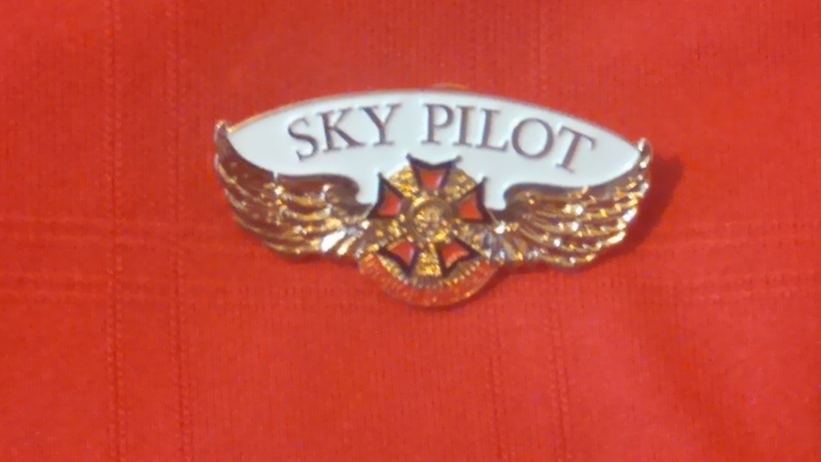

February 2021

Military Order of the Cootie
Sky Pilot’s Manual and Handbook

Like any major project, there is no way I could have developed and written this entire Manual and Handbook by myself. I have a lot of people to thank for their help.

The first of those is my wife who acts as my editor. A critical task for a writer who has never been a great speller.

When researching this Handbook and Manual we used ‘The Chaplains Handbook for the Veterans of Foreign Wars of the United States’ and 2012-2013 edition of ‘A Handbook on the Duties and Functions of a Post Chaplain’ from the VFW Department of Oregon as resources for ideas.

In the process of preparing this book, we learned the Past VFW National Chaplains Ted Bowers and Peter Hook developed the original VFW Chaplain’s Manual. We want to thank them for their efforts to improve the caliber of VFW Chaplains. We would be negligent if we did not also recognize and thank all those VFW/MOC chaplains who advised and supported them in their efforts. Chaplains from several states developed their own state guides based on the VFW Handbook; they too deserve recognition.

We also formed a committee of present and past Cootie Grand Chaplains and VFW past National Chaplains to assist. The committee members had a major part to play in the completion of this book. They either wrote or helped edit the text. They also submitted prayers and service formats for The Handbook. The members of the committee are Tom Darling from the Department of Washington, Peter Hook from the Department of Pennsylvania, Dale Iannello from the Grand of Washington, Eric Shumaker from the Grand of Texas, and Jennifer L. Smith from the Grand of Michigan.

I want to give my heartfelt thanks to each and every Sky Pilot and Chaplain who helped make this publication happen.

Allan T. Perkins
Supreme Chaplain, 2014-2016

Table of Contents

Manual

Introduction ……………………………………………………………….. M-1
What is My Job? …………………………………………………………. M-5
The Prayers of the Ritual …………………………………………. M-13
The Sky Pilot and the Ritual ……………………………………. M-19
Public Prayers and Events ………………………………………. M-27
Sky Pilot Counseling ……………………………………………….. M-51
Cards and Notes ……………………………………………………… M-55
Hospital Visitations …………………………………………………. M-59
Sky Pilot Reports ……………………………………………………. M-65
Supreme Awards ……………………………………………………. M-69

Handbook

Prayers found in the Ritual …………………………………….. H-1
Simple Table Grace ………………………………………………….. H-2
A Native American Benediction ……………………………….. H-3
Table Grace for a Banquet (General) ………………………. H-4
Installation Banquet Invocation ………………………………. H-6
Installation Banquet Benediction …………………………….. H-7
Refrain from ‘Gather the Spirit’ ……………………………….. H-8
Memorial Service for a Cootie …………………………………… H-9
Optional Funeral Benediction ………………………………….. H-12
Traditional Funeral Service ……………………………………… H-13
Funeral Homily for a Cootie ………………………………….…. H-15
Committal Prayer …………………………………………………….. H-18
Graveside Palm Cards ……………………………………………… H-19
Four Chaplains Remembrance Prayer ……..……………… H-21
Veterans Day Breakfast Invocation …………………………. H-23
Veterans Day Breakfast Benediction ………………………. H-24
Veterans Day Prayer ……………………………………………….. H-25
Veterans Day Benediction ……………………………………….. H-27
POW/MIA Remembrance Day Prayer ………………………. H-30
Voice of Democracy Luncheon Invocation ………………. H-31
Voice of Democracy Luncheon Benediction ………….… H-32
The Young Dead Soldiers Do Not Speak …………………. H-33
In Flanders Fields …………………………………………………….. H-35
Note Cards – Supreme ……………………………………………. H-37
Note Cards – Grand …………………………………………………. H-40
Sample Sky Pilot of the Year Letter ………………………… H-43
Tim LaHaye Memorial Prayer …………………………………… H-45
Memorial Blessing ……………………………………………………. H-46
The Snow Rose Ceremony ……………………………………... H-47

Military Order of the Cootie
Sky Pilot’s Manual and Handbook

Manual

Introduction

If you thumb through this book, you will notice several interesting things. First off, it is written in very simple language. We realize that, like most VFW Chaplains, most Sky Pilots did not go to seminary and do not have a formal education in religion. Where formal religious terms are needed, we used them and tried to explain them in simple terms. But, most of the time we have deliberately kept it simple and kept away from ‘Theological Technical Terms’.

Next you will note that this book is divided into two parts. This first part, The Manual, will provide information which can be used as training materials for new Cootie Chaplains or a ready resource for the experienced Sky Pilot.

Like their VFW Comrades, Cootie Sky Pilots tend come in various varieties. Most volunteer, or are volunteered, to serve as their pup tent or district Sky Pilot for a year or two. Usually to fill a slot nobody volunteered for, or for which they are uniquely talented, or as a step to higher office. But others see serving as a Sky Pilot as a vocation. It is a job they take as a sacred responsibility. Also, a few are ordained ministers, but the vast majority are not. Even ordained ministers come with a very wide range of education and experience. Some may have a masters or doctoral degree. Many have a bachelor degree. And some were ordained because they were commissioned to perform a specific religious task. They may have very little training, except in that specific task. But, because being a Sky Pilot is different than any other VFW/Cootie office, and serving as a VFW/Cootie Chaplain is very different than the tasks of a parish minister, all these comrades need some training when they take office the first time.

Hence, the manual portion.

The second part, the Handbook, provides sample prayers, services and reports to make your job easier. It is a quick, ready reference to the Sky Pilot’s most common tasks. We will often provide you with information in the Manual, then provide samples in the Handbook. To make it easier to see where you are, the Manual section will be page-numbered M-1, M-2, M-3, etc.; while the Handbook section will be page-numbered H-1, H-2, H-3, etc.

You will also notice that we are providing the Sky Pilot’s Handbook and Manual in full page, loose-leaf format. Why? Because that is the way the MOC Ritual is provided. You can put them into separate binders, or both in the same binder and have everything you need readily at hand.

Next, you will see that we printed everything in big, easy-to-read text. Many of us, including your Supreme Chaplain, are not getting any younger and do not see as well as when we were younger. The larger print also makes it easier to hold and read during a scratch, service, or ceremony.

You will notice that wherever a prayer, poem, service outline, or other example is used, we provide a citation giving credit to the author, if known. While we want you to freely use the examples and other resources provided, we ask when you do, you give proper credit. Additionally, we see this book as a living document. It will updated with new and additional information and examples as needed.

Finally, in the supreme by-laws pup tents have ‘Sky Pilots’ and Grands and the Supreme have ‘Chaplains’. In this book we will deliberately use these terms interchangeably. We have been conscious that some see being a Chaplain as a ‘minister’ and a Sky Pilot as something less. Or that those who come to the job already ordained by some established religious organization are ‘real’ while the others are less than. Those who serve the spiritual needs of their comrades are all providing a blessing and should never be demeaned because they come to the job with a different history.

However, no matter at what level you serve, or whether you refer to yourself as a Chaplain or Sky Pilot, be proud of the service you provide. Wear the official MOC Sky Pilots wings. This unique pin identifies you as someone who serves the spiritual needs of the members of the organization. It also is unique enough that people will ask you about what it means. That is a natural opportunity to tell them about VFW and MOC. You become a Sky Pilot and a recruiter at the same time.

Finally, this book is not part of the Bylaws and Ritual of the MOC. It is a training manual and a guide to the best practices. With the exception of short quotes in the next two chapters, discussing the job of the Sky Pilot using the Ritual, the Ritual and Bylaws are not copied here. So during official meetings and functions of the Military Order of the Cootie follow the official Ritual, and read the prayers provided by Supreme Headquarters. For all other tasks the Sky Pilot performs, you may look here.

It is the hope of all of us who worked on this book that it will be helpful to you as you go out and become a blessing to our Cooties and fellow veterans.

What is my job?

Over the years I, and just about every other Grand or Supreme Chaplain, have had dozens, if not a couple of hundred, frustrated new Sky Pilots come and ask “What am I supposed to do?”

Then, they usually say something like, “My Commander says all I have to do is read the prayers from the Ritual.” They sometimes also say, “I checked the Bylaws and it doesn’t say anything useful.”

It is very easy to understand their frustration. Section 319 of the Supreme Bylaws covers pup tent Sky Pilots. All it says is:

“The Sky Pilot shall perform such duties incident to their office as the occasion may require or as the Seam Squirrel may direct.”

Likewise, in addressing the duties of Grand Chaplains section 418 of the Bylaws says:

“The Grand Chaplain shall perform such duties incident to the office as the occasion may require or as the Grand Commander may direct.”

And again, Section 517 of the Bylaws directs:

“The Supreme Chaplain shall perform such duties incident to his/her office as the occasion may require or as the Supreme Commander may direct.”

It seems at first blush, that these sections do not tell us much. But the truth is, there is much information we can glean from them.

The first, and most obvious, lesson to learn here is that a Sky Pilot will perform duties “as may be required by the occasion”. In other words, we may find ourselves operating in situations and conditions we are not expecting. That we are expected to operate out of the box. Even so, we are expected to perform our duties with reverence and respect.

Let‘s look at some examples. Many years ago, We were at a funeral for a comrade we only slightly knew. While many of those present were wearing our VFW caps, we were informed we were not to play a part in the ceremonies.

The family were from another town, and had no church home in the state, so they only planned a graveside service and an informal wake at a local restaurant. When we got to the graveside and were ready for the committal service, no other clergy were present. A family member pushed a Bible into the post chaplain’s hands and said, “Read this and pray for him, please.” So he did. Not well, because he was upset over a young person close to me passing away, and was not prepared. But he did it. We also learned a lesson that day. A Sky Pilot’s job does not stop when he or she leaves the scratch, and you must always be “prepared to perform such duties incident to the occasion”.

There are all types of unexpected responsibilities, and changes from the norm, to which we must react. The first time we was sitting in a post canteen and a VFW member said, “I have something I have to tell someone,” we found ourselves getting just a little frightened. We had no idea what my comrade was going to say, or what we was supposed to do with the information he provided. Over the years, like so many other Sky Pilots, we learned to listen and how to handle what was being said. Many Sky Pilots find they do their most important work with “stealth counseling” at the post canteen, bingo or steak night dinner.

While much of what we do as Chaplains, require us to perform our duties in an attitude of sober respect; we are Cooties. We should be willing and able to use humor in our work as a Sky Pilot.

On another occasion, we were at a Cootie district meeting; once again sitting in the back, not planning to be part of the proceedings, when we were asked to fill in for the District Sky Pilot, who was ill.

When it was time for the Prayer for the National Home, we walked up to the alter, accepted the strange (years out of date) copy of the Ritual from the District Seam Squirrel, and began fumbling for the proper page. Several Cooties helpfully called out page numbers at random. We found the right page and delivered the prayer properly. However, to this day when we approach the alter for a prayer during a scratch of our local Pup Tent, our closest friends gleefully call out random page numbers. Our response is usually to quiet ourselves for the prayer. But, sometimes, as we are walking up to the alter we will laughingly correct them with my own obviously factitious page number.

Of course this brings us to the most common known duty of a Sky Pilot, to deliver prayers during scratches and meetings. We will speak more about delivery in a later chapter. However, we want to look briefly at the prayers in the ritual.

While most Chaplains know of the three prayers used during a Pup Tent scratch, there are really quite a few prayers in the ritual. A ready reference list of prayers found in the Ritual has been provided in the Handbook on page H-1.

A Sky Pilot may also find the need to visit Cooties and other comrades in the hospital; either as part of a wider Cootie function, or alone as part of their Chaplain duties. We will speak more about these duties in future chapters, however, remember they should always be accomplished with respect, reverence, and good humor.

It may not make much sense to some that we use the words ‘humor’ and ‘reverence’ in the same sentence. But look at it this way; as Cooties we are expected to “Keep ‘em smilin’ in beds of white”. So joking and humor are a big part of what we all do. But as Sky Pilots, we also recognize that we perform a sacred duty. One way this may affect what we do, is the types of jokes and pranks we perform. The example we set is seen by those around us, and if we have a good reputation; followed by our fellow Cooties.

Few of us have training or experience in counseling. But we often find those in need. So we have added a short chapter to help.

There are other tasks we perform regularly also. These include completing and submitting reports; sending notes and cards to comrades; and submitting, reviewing, and presenting awards. So we have provided short chapters for each of these. But, as we noted earlier, you never know when you are going to be asked to perform some duty “as the occasion may require”.

Before we leave this chapter, there is a very important point we should make. The VFW, and therefore the MOC, is not an “old boys club”. While our Congressional Charter requires our members to be combat veterans, we are a very inclusive veteran’s organization. We cheerfully accept members from all branches of service, all wars, and all conflicts. In the same way, we accept members from all cultures, faiths, and religions. This means that while the VFW/Cootie Chaplain has his or her personal faith, and they should cherish and grow it. At the same time, the Chaplain must serve all members spiritual needs, without offending the member.

This means prayers and services must be worded so that they do not offend those of other faiths. It might also mean a good Sky Pilot may want to learn basic beliefs and prayers from other faiths, so that they can be used at the appropriate time. For example; use a prayer from the members own faith when serving at a memorial service at their passing.

So, you can see, the Sky Pilot’s job really is a lot more than simply reading prayers from the Ritual during scratches. However, the Ritual and prayers are still our most common task, so let’s look at them in the next three chapters.

The Prayers of The Ritual

As we suggested in the last chapter, just because they have been in numerous scratches, most new Sky Pilots know they have to deliver three prayers at each scratch; The Opening Prayer, the Prayer for the National Home, and the Closing Prayer. The opening and closing prayers are fairly straight forward. They each have their precise location in the ritual and are very well known. So, you should not have a lot of trouble with them if you practice before the scratch.

Some Sky Pilots take pride in memorizing these prayers to deliver at the appropriate time. This Supreme Chaplain does not. Experience has taught that we all have memory lapses from time to time. So, while we might be able to recite the most common prayers in the ritual, we should always take the Ritual to the Alter with us. A Sky Pilot might see it as “safety before style,” not that there is anything wrong with style also.

In fact, carrying your ritual book to the Alter can be seen as setting the tone for the coming prayer. In the same way, walking back to your seat says, “let the scratch and fun continue”.

So, you should have no trouble with the opening and closing of your scratch. But we need to spend a few minutes talking about the Prayer for the National Home.

There are actually two of them. This is the original prayer for the National Home:

“At this hour of the evening, the children of our departed comrades at the VFW National Home for Children are Kneeling at their bedsides in reverent prayer to Almighty God. Let us turn our thoughts towards Eaton Rapids, Michigan, and with bowled heads join them in their prayers
Repeat after me
“Suffer the little Children to come unto me And forbid them not For such is the Kingdom of God”
May God bless our National Home
Amen”

This prayer has been used by the both the VFW and the MOC for decades. However, several years ago the VFW replaced it with this prayer:

“Almighty God, we ask Thy Divine blessing on the widows and children in our National Home. May Thy Divine spirit be within them forever, giving them health and guiding their lives. Trust us always, to honor our departed comrades.
Amen.”

However, the MOC did not delete the older prayer. It became an alternate prayer and was to be used at times other than the evening when the children would be going to bed and reciting their bedtime prayers. But, that has changed. At the July 2017 Convention, the verbage in the Ritual was changed to delete references to the time of day. The effect is that either prayer can be used any time of day.

There are other prayers in the Ritual a Sky Pilot must deliver from time to time. The most often heard of these are the Prayer for Newly Installed Officers and Prayer for Draping the Charter.
Both of these prayers are provided as part of a larger ritual.

Of course, normally new officers are only installed after elections, at the end of the program year. However, you may also have to install a new officer after an office is vacated in mid-term for some reason. The same prayer from the Ritual should be used.

But unfortunately, comrades pass on at unexpected times. Because of this, you should always be prepared to drape the charter at every scratch you attend.

One of the saddest things a Chaplain must do is preside at a memorial or burial service. There are four prayers in the Ritual for these circumstances. The first is the Prayer at a Memorial Service, it is used when the pup tent holds a formal Cootie Memorial Service for one or more members.

If the pup tent has a service at the funeral home, or church, for a member who has passed they will use the Burial Ritual and the Sky Pilot will deliver the Burial Prayer at the beginning of this service. If the pup tent also proceeds to the cemetery, there are two more prayers the Chaplain will deliver. The first is a short Committal Prayer and the second is a Benediction. All of these prayers are provided in the MOC Ritual.

We will speak more about these different types of prayer in another chapter.

There is one more very important point we need to cover before leaving this chapter, however. How you deliver a prayer. It is critical to the mood you set. If you deliver the prayer in the slow, sincere voice of a sage, you set one mood. But, if you stutter, mispronounce words, and seem unsure of yourself - or run through the prayer at the speed of a buzz-saw - you will set a completely different mood. You should sound confident without sounding like you are reading.

If you read too fast, it is much more likely you will skip or mispronounce words. Reading too fast also makes it much harder for those present to hear and understand what you say.

We all make the occasional mistake; even if we have been delivering the prayer in question for many years. The reflex is to stop, and correct our mistake. Try very hard to fight that reflex. If you keep on going as if there is no problem, few people will notice, or comment on the mistake. However, if you stop and correct your mistake, everyone will be aware of it.

Finally, practice is important. So, if you go over your part; reading it aloud several times, until you are comfortable with it before the scratch, you will do much better. As we said, we all make mistakes from time to time. But, there will be much less of them if you practice and deliver your prayers in a slow careful voice.

The Sky Pilot and the Ritual

It the last chapter we looked at the prayers found in the MOC Ritual. In this one, we will look at other places in the Ritual the Chaplain has a part to play. Before we start back to the ritual, however, here are a couple of pointers to make your life as a Sky Pilot much easier.

It is a good idea to always have the latest edition of the Ritual. Slight changes in the Ritual occur almost every year. Over three, four or five years those ‘slight changes’ add up to a fair amount of change.

When you do obtain a new edition of the Ritual, mark it to identify the prayers we looked at in the last chapter (and the ritual sections we are discussing in this chapter) for easy use. When we say “highlight”, we are not really talking about using a pen or marker. You want to be able to quickly turn to the section you need, so you do not break the flow of the ritual thumbing through pages. Some experienced Sky Pilots use paper clips to mark sections of their Ritual to which they want to quickly turn. Others use stick on loose-leaf tabs. There are even multi-part bookmarks, intended for reference books and Bibles, which serve this purpose very well. Whatever method you choose to use, we still recommend you ‘markup’ a new copy of the Ritual as soon you obtain it.

One of those sections you may want to mark in your Ritual, is initiation of new Cooties.

First Degree Initiation

When you initiate a new Cootie into the First Degree, the Degree of Incubation, it is an exciting time for everyone in your pup tent. New Cooties help you build your pup tent and helps you “keep ‘em smilin’ in beds of white.”

But you have a large part to play in the ritual of the first degree.

As Sky Pilot, yours is the first station to which those Atoms who are to become Nits will be escorted. There will probably be a lot going on; the future Nits will be blindfolded and will have walked backwards to your station, maybe through an obstacle course. Many Cooties may also be playing with their loudest ‘cootie toys’. Through all this, it is up to the Sky Pilot to impart the first official information about what the Military Order of the Cootie is really about. The impression you make to these new Nits may strongly influence their view of the MOC.
You should present your advice in a way that emphases the importance of what you say. Put plenty of inflection into your voice and stress the most important parts of your speech. For example in the first few sentences:

“Most innocent Atoms, the time is rapidly approaching when you will be transformed from an Atom to a Nit. I hope the transformation will be of benefit to you by increasing your circle of friends and teaching you that a smile and pleasant word is always worthwhile.”

Using the inflection of your voice, and your pacing, you can put a little bit of stress on some words and more emphases on others.

You have heard us say it before; but, practice your portion of the Ritual until you are comfortable with it.

One last note about the first degree, though. While the Sky Pilot’s portion of the Ritual for initiating an Atom into the First Degree all runs together in the Ritual Manual, there are really two parts for the Sky Pilot to read. The first, much longer portion, is spoken to the Atoms being initiated. The second is an instruction to the Shirt Reader. A smart Chaplain will pause briefly between the two, and pitch their voice slightly differently for the second. They will also move their head and visual focus to the Shit Reader. That way, it is obvious to all in attendance that you are talking to someone different.

Second and Third Degree Initiations

There is no portion of the Second Degree, the Degree of Transformation, ritual for the Sky Pilot. Even so, you should be acquainted with the complete ritual for the second degree. You very well may be asked to ‘fill in’ for another officer who is not available for the ceremony.

In the Third Degree, the Degree of Aggravation, ritual you again have an important part to play. This section is smaller than the Sky Pilot’s speech in the First Degree ritual, but no less important. This is, in many ways, a harder section to deliver properly.

While the terms are humorous, the tenor of the ritual is not. It should be delivered by the Chaplain using their ‘prayer voice’. That same slow, solemn voice they use at the Alter. There are several terms in this short passage which often prove to be a trap for many Sky Pilots. For example; ‘Specie Pediculi’, our favorite term within the MOC for ourselves.

Instituting a Pup Tent

The Chaplain has a part to play in instituting a New Pup Tent. It is very much like the instructions the Sky Pilot gives for the First Degree, with parts of the instructions from the other degrees added to round out the initial instructions to new cooties in a new pup tent.

It goes without saying by now that you should practice your portion of the ritual if you are asked to help institute a new pup tent. It is even more important that the Sky Pilot helping to start a new pup tent do an excellent job. You will be the person their new Sky Pilot looks to for instruction on how to best perform their duties. Train them well.

Instituting a Grand Pup Tent

Instituting a new Grand Pup Tent is indeed a joyous chore. However, it is also a task which is not often required.

The Ritual for instating a Grand Pup Tent is very short; barely one page in The Ritual of the MOC. It is hoped that the Installing Officer will select those who will serve as Acting Adjutant, Acting Chaplain, and Provost Marshal in advance so that these officers may practice their parts.

You should know that there is a place in The Ritual for the Acting Chaplain to deliver ‘the Prayer’. However no prayer is provided. So, the Acting Chaplain will either have to prepare a Prayer in advance, or deliver an extemporary (off-the-cuff) prayer. If you know, or suspect, you will be asked to serve as the Acting Chaplain, it would be a very smart move to bring an appropriate prayer to the installation ceremony. Just in case.

Memorial Service and Burial Ritual

The Chaplain delivers a prayer as part of both the Memorial Service and Burial Ritual. However, in the Burial Ritual, the Sky Pilot is also asked to deliver a short message. A moving homily is provided for you to use. However, there an instructional note is also provided, it reads:

“S.P. shall repeat the following or make an address of similar length.”

As a rule, it is usually best to use the script as provided.
The exception would be if;
- The Sky Pilot has a close relationship with the family of the Cootie in question. And;

- The Sky Pilot knows enough about the Cootie, and their family, to add personal touches to his homily. And;

- The Sky Pilot is very comfortable speaking in public under stress.

As we have said several times in this, and the chapter before, practice is important. In these solemn occasions, the Sky Pilot has great influence on the tenor of the activities. It is up to them to deliver all prayers with respect and reverence.

Public Prayers and Events

If you, or your Pup Tent, is well known in the local veteran community, or you serve at the Grand or Supreme levels, you will frequently be asked to participate in public events or to pray in public. We will look at several types of activities and events. However, we should review a few points first.

When you, as the Sky Pilot, participate in a public event everyone knows you are an officer of the MOC. So you represent the Cooties to the public. What type of image are you going to present?

When in public we need to act professional, but we do represent a fun organization. So what does that mean? Well, if it is a very somber event, you should act accordingly. However, it is a light hearted event, you may want to tell a joke. Even so, ‘off colored’ jokes are never appropriate in public. Neither are jokes which make fun of, demean, or ridicule any religious or ethnic group. If it is an appropriate event for a joke or story, your story should be relevant to the event. Telling a humorous story about your time in combat would be appropriate for a veteran’s reunion, but probably not at the mayor’s conclave on the homeless.

Being professional also means dressing appropriately. If you are representing the MOC at a public event, especially a veterans or military event, you probably should be in formal Cootie uniform. Unless it is specifically identified as a ‘casual’ event, that means long white pants, white shoes and red socks, red blazer, and appropriate shirt and tie. Of course, topped off with your official MOC cap with the appropriate tassels. It would also be appropriate to wear your Sky Pilot’s wings also.

Public Prayers

Many of the ideas we looked at concerning prayers from the Ritual, also true here. So, let’s review them;

Set the mood. Invite the audience to pray with you. If you are praying at a true public event, where a large portion of the audience are civilians, you probably do not want to shout, “Parade Rest, Uncover.” However, it would be appropriate to give an inclusive invitation, such as, “Please prepare for prayer according to your custom”. Those VFW and Cootie members in the audience will indeed come to parade rest and uncover, others will bow their heads, and some may just sit quietly. That is still okay.

Use inclusive words, which would be acceptable to all faiths and are not seen as offensive to any.

Speak in a slow, somber voice, pronouncing each word carefully.

Know what you are going to say before the event. It is no insult to have prepared remarks. It will be viewed in a poor light if you stammer and stutter because you cannot think of what to say.

If you do mispronounce a word, or forget a word, do not stop. Keep going. The audience will be less likely to note the error.

Practice, practice, practice. Remember you represent the Military Order of the Cootie. When appropriate, you can be funny, but you may not be unprofessional.

Remember that the Sky Pilot’s task at public events is not to impress the participants with their language skills; but to offer spiritual guidance. If a few simple sentences will serve the purpose, do not feel you must offer paragraph after paragraph of verbiage. You do not want to be the overly verbose preacher others make fun of.

There are many types of prayers we might be asked to give in public. One of the most common types of prayer you might be asked to give is a Table Grace at a social event.

Table Grace

Along with the ‘bed-time prayer’, it is one of the most well-known types of prayer. As a child, most of us were taught a simple grace at home. The key to these simple prayers is to thank the Divine for our food and to ask a blessing on those who prepared it. So, the simplest might be;

“Holy God, thank you for this food, and bless those who prepared it.
Amen.”

Sometimes a simple prayer such as this is all that is needed. For your reference several simple Table Graces are provided starting on page H-2.

Many times, however, when you are asked to offer ‘grace’ at a banquet, or similar event, a bit more is called for. You may find it appropriate to offer blessings for the event. You may also find it appropriate to offer blessings for key people present, or to offer ‘traveling mercies’ for the participant’s trips home. Samples start on page H-4.

You might also be asked to offer other types of prayer at public events, especially during patriotic holidays and events.

We strongly caution every Sky Pilot here to remember they are not in their home church, chapel, or temple. Time constraints of the event have to be strictly observed. We know of more than one minister who was urged off the platform when their prayer ran much longer than the allotted time. In one case we know of, a minister whose Veterans Day benediction went on for over ten minutes. Finally the Master of Ceremonies took the mike, to the cheering of the audience, and announced it was past 11:00 and time for the moment of silence and flyover by military aircraft.

These prayers must be inclusive to respect all faiths of the veterans, family members and civilians present. This is also not a sermon; therefore should not come off ‘preachy’. After many years of experience, we can tell you that a minister or Sky Pilot who doesn’t follow these simple rules will not be invited back.

Typically, at these events one to three types of public prayer might be offered. If all three are offered they might be referred to as the Invocation, Prayer of the Day (or Event), and Benediction.

Invocation

An Invocation, at such events might also be referred to as an ‘Opening Prayer’. This is usually a very short prayer at, or near, the opening of an event serves to invite the Divine’s blessings the event, offer brief words of thankfulness, and recognize the sacred nature of the event. Typically a good invocation sets the mood of the event in a few short paragraphs.

Sometimes invocations and others prayers do not start out that way. One of the author’s favorite hymns from his church’s modern hymnal is “Gather the Spirit” by Jim Scott. The refrain of this song makes a unique and emotional invocation for festive or informal occasions. It is provided on page H-8.

The Prayer of the Day

The Prayer of the Day is usually the main prayer at a public event. If only one prayer is offered this is usually it. Also, if an invocation or benediction are not offered, a sentence or two in this prayer should cover those purposes also. The Prayer of the Day invites the attention of the audience and the Divine, drawing everyone into the reason for the event. It is normally longer and should follow both the purpose and theme of the event. It may also be used to charge the audience members to action in the cause of the event. At most events we have been invited to, the event organizers will provide an approximate time limit for this prayer; usually around three to five minutes. However, a lot can be said in three to five minutes. Sample Prayers of the Day for various holidays are provided starting on page H-20.

Because they are great resources and often used, we have also included John McCrae’s poem, On Flanders Fields, on page H-34. Starting on Page H-32 we have included The Young Dead Soldiers Do Not Speak, by Archibald MacLeish.

Benediction

Very simply, a Benediction is a ‘closing prayer’. It serves three main purposes. First, obviously, it signals the end of the event. It also is used to thank the Divine presence at the event and extend what is often referred to as “traveling mercies”. Asking the Holy to protect everyone present on their way home. It may also be used to provide a final challenge to those present to live up to the ideals of the event. Once again, thought, a benediction only needs to be a few sentences; no more than a long paragraph in length. Benediction samples are provided starting on page H-7.

Events and Services

There is a wide variety of public events and services a Sky Pilot may be asked to participate in. Some of these opportunities occur because your pup tent planned and presented them. Some of them will present themselves because the community plans a patriotic event, and you are the spiritual leader of a local veterans’ organization. But, many of them, like funerals, occur because of unplanned events.

There are dozens of small guides, often referred to as ‘minister’s manuals’. Some come from the publishing arms of various denominations and faith groups, others are written to be used across denominational lines. The smart Sky Pilot will obtain several of these little books, from different points of view, to help with in preparing for some of the services and events we discuss here. They, like The Handbook in the back of this work, will have outlines to guide you in various types of services. These little books are an additional resource for you.

We have one final thought on public events and services. As a VFW Chaplain or MOC Sky Pilot, you represent the organization, its mission, and interests. We must insure that when we appear in public in Cootie uniform, or even wearing a ‘collar cootie’, that we do nothing which will put the MOC in a bad light. One of the hardest lessons for many Sky Pilots to learn is to put the organization’s interests before our personal interests, or to put the interests of those we serve above our own interests.

Funerals

Every ‘minister’s manual’ we reviewed gave the same advice as the first step when a member of the congregation, or their family, passes away. Usually it is something like, “the pastor should immediately visit the family and provide grief counseling and assistance in planning the funeral.” This is indeed excellent advice for a parish minister.

However, your situation is somewhat different. You should never assume you will be officiating the funeral unless the family asked for your help in advance. If the family regularly attends religious service, you must expect that the family’s pastor, priest, rabbi, or other clergy will officiate at any funeral services. Even if your veteran, and their immediate family do not attend services regularly, the extended family may insist in using clergy they are familiar with. In these cases, you must always yield to the needs of the surviving family.

You may be asked to assist the family clergy in planning services. In which case, provide any and all assistance you can, but do not attempt to take the lead. Many times, the family will want a VFW or MOC Memorial Service during the viewing. You should coordinate this with the funeral home and the local Commander or Seam Squirrel.

Especially as a Pup Tent Sky Pilot, what you can, and should, do is contact the immediate family and let them know that you, and the other members of the pup tent, are there to support them in their time of grief. Listen to their needs and react accordingly.

A Sky Pilot serving at the Grand or Supreme Level, may find a card is a more appropriate way to respond; allowing the local Chaplain to call on the family. However, if the comrade who passed is a close friend, or a member of your own pup tent, you still may want to call a family member to whom you are close.

If the family does not have a ‘church home’ you may be asked to assist with the funeral arrangements. You should always be prepared.

Part of your preparation should include knowing what services are available for veteran funerals in your area, so that you can make suggestions to the family. For example:

Is there a national or state cemetery in your area? If so, do you have contact information for them?

Is there a military base close by which will provide minimum honors at the internment? Is there a VFW Post, or Cootie Pup Tent, in the area with an Honor Guard to provide additional honors? If not a VFW or MOC Honor Guard? What about an honor guard from another veteran’s organization? For example, in some towns the American Legion provides these services.

Are other organizations such as the Patriot Riders available? In some locations the Patriot Riders will escort the veteran and family from the funeral home to the graveside, then surround the graveside with members holding American Flags. This serves as a protection for the graveside service, helps to give the internment more intimacy, and is a touch which will be greatly appreciated by the family.

If the family requests a wake or family gathering after the funeral services, is your post home available and appropriate for such a gathering? The canteen or bar is probably not the appropriate location. However, if your post includes a large hall or meeting room available for public activities, it might save the family money and be an appreciated touch. Some posts provide such services free to post member’s families as a matter of practice. The auxiliary in some posts even provide a meal or refreshments for funerals of members or other local veterans.

What other services are available in your community? In some of the larger National Cemeteries, the Memorial Ladies offer condolences to the family at the gravesite ceremonies.

One of the questions families ask most often when planning a funeral is, “How do we get a flag for his casket?” The answer is that the funeral home should have a stock of flags on hand. When they serve a veteran and use a flag, the federal government will replace it upon request. The family does not ever pay for the flag for the coffin. In fact, Federal rules task U. S. Post Masters to keep flags on hand to provide to funeral directors as required.

If the family does come to you and request you officiate at the funeral, you should listen to their desires, and make suggestions to help them plan the services which fits their custom and provides the most consolation to them.

Remember, these services are to console the family, not show off your talents. Make every effort to meet their needs.

There are four basic types services involved in a funeral. The family of the deceased may ask for any of them, but very rarely all of them. These four types are:

Viewing
Funeral Service
Committal Service
Wake or family meal

The Viewing usually happens at the funeral home, often the day before the funeral itself. Although, when the funeral, or memorial service, is held at the funeral home, the viewing may be earlier on the same day as the funeral, so that family and friends can come for the viewing and stay for the funeral service. The viewing allows the friends and more distant relatives to offer condolences to the immediate family and to pay final respects to the deceased.

The coffin may be opened or unopened depending on the desires of the family and the condition of the deceased. If the coffin is left closed, the flag will cover the coffin. If it is open, the flag will remain on the coffin, but be folded back from the head to allow opening. According to the U. S. Flag Code, no flowers or other items should rest on the flag.

As the officiating Chaplain, the family will probably want you available to answer questions, provide condolences and counseling, and meet with family and friends as required. You should serve as a calming influence. If the pup tent is going to perform a ‘Cootie Memorial Service’, the beginning, or end, of the time set aside for the viewing is usually a good time.

The funeral service itself requires more thought and planning on your part. In recent years, this service might also be referred to as a ‘celebration of life’. This is important because it helps to dictate the tenor of the service. As with the viewing, the immediate family dictates the type of service desired.

Such services may be very formal and traditional, or contemporary and less structured. Either way, as officiating chaplain you should control the pace of the service. If you, as your pup tent’s Sky Pilot are officiating, the family probably does not have a church home and the service will be held at the funeral home. In such case, a simple service such as the one outlined on page H-9 may prove comforting to the family and friends present.
The Homily should be short and simple. As a rule, no more than 5-6 minutes. You should also ensure it is comforting and uncontroversial. If you know the family has a Christian background, a homily such as the one starting on page H-15 may be helpful. Remember that this homily is merely an example, and you may wish to change it. Otherwise a short homily about the deceased veteran and how we can help those close to them heal might be appropriate. If the family requests a more formal funeral service, you might consider the example starting on page H-13.

The ‘Committal Service’ is a very short graveside service. Many National and State cemeteries have dedicated ‘committal Shelter’ design for these services. If there is no such a shelter, the Committal Service will often take place at the actual graveside.

We have provided cards to be held in the palm of the hand on page H-19. These cards allow the pup tent to provide a very simple graveside ritual.

If military honors are to be provided, the Honor Guard will offer them first. This includes presenting the flag to the next of kin and the playing of ‘Taps’. If a gun salute is offered, it will be just before the playing of ‘Taps’.

These are all very moving ceremonies and it can be expected that the next of kin and other family members will be brought to tears. So, it would be appropriate to offer a few short words of comfort, including ensuring the family that you, the Pup Tent and VFW Post members are available to assist in any way possible.

Finally, the ‘Committal Prayer’ is designed to offer comfort and add finality to the service. A sample Committal Prayer are offered on Page H-18. After this prayer, you should offer personal words of comfort to the next of kin and other close relatives present.

The family may wish to meet for a meal and companionship after the Committal Service. Sometimes called a wake. It is an informal chance to meet and talk, comparing stories of the deceased. These gatherings can be very important for healing and the dispelling of grief. If invited, the Sky Pilot should attend and offer whatever assistance they can. Family members and friends may well approach you to offer stories. Telling these stories can prove to be an emotional release for both you and the family. So, listen carefully and show caring interest. It may prove to be the most useful task of your entire day. Family members, especially those who have not seen the deceased in some time, may also ask you for stories of their loved one. If so, offer them with compassion and good will.

Speeches and Special Days

As an officer in your local Pup Tent you can expect to, from time to time, be asked to play a special part in celebrations for Patriotic and other holidays, or local events. Some of the most common days towns and cities have celebrations on are:

Memorial Day (last Monday in May)
Flag Day (14th of June)
Independence Day (4th of July)
Labor Day (1st Monday in September)
POW/MIA Recognition Day (3rd Friday in September)
Veterans Day (11th of November)

Many towns will have a celebration at city hall, the local cemetery, or a parade down the main street on these days.

You may be asked to pray at these events. Starting on page H-20, sample prayers for these events are offered. Some are identified as for a breakfast or luncheon, but can easily be used for other occasions.

Ribbon Cuttings

Sometimes, you will be asked to attend a ‘Ribbon Cutting Event’ in your area. These might be for the opening of a new post, a monument or memorial, or for a new Veterans Administration or state veterans’ facility. As a rule, you should attend these events when invited. It is a way to show veterans in a positive light in the community. Unless you have been asked in advance to provide a prayer or speech, your job will be to ‘be seen’. However, this too is really is not as easy as it sounds. Government officials, politicians, members of other veteran service organizations, and the media will be everywhere. Just by being there, what you say, and how you present yourself, reflects on the MOC and veterans as a whole.

You should dress in “Cootie Garb” appropriate to the event and wear you official MOC cap. At such public events, it is always better to dress up, then to find yourself inappropriately underdressed. Being inappropriately underdressed always puts you, and your organization, in a bad light. As a Sky Pilot, it is also always appropriate to wear your ‘Sky Pilot’s Wings’.

You may like to wear western hats, ragged shorts, t-shirts with suggestive mottos, or your worn-out camo coat with 30 patches; just not when you are ‘representing’. Do not be fooled, as a MOC member, if you are at a public event, you are ‘representing’. Without having to say a word, others will see you as representing the organization and veterans at a whole. If one of the 30 patches on that camo jacket reads ‘VFW’ or ‘MOC’, you are representing the organization to those around you. And, not favorably.

But, just as important is what you say and do. If asked what you think of another group or well-known person, always have something positive to say. You may think you are talking to a close friend, or someone with your views, but in such situations, many more people can overhear you. If they don’t like it, or find something negative in what you say, it will be passed off to dozens of other people. The result may be that you lost possible new VFW or MOC members. Or even worse, give the community a bad taste for Cooties. One careless remark in public can negate the good will earned with a hundred of hours of hospital work.

However, if you dress properly, act politely, and say positive, inviting things; you will be a great ambassador for the VFW and MOC. That is what we want. The more we are seen in public being friendly, positive and helpful, the better the community thinks of VFW and the Cooties. And let’s be honest, we still have that “the VFW and veterans organizations are just glorified bars” stigma to overcome.

If you are invited to a public ribbon cutting or dedication for the construction of a building, it is smart not to rush over and grab the ‘big scissors’ or ‘golden spade’. When called forward for the ritual event, there will probably be several governmental officials and politicians. The best move is to stand at the edge of the group and, as they are sorted out, allow them to assign a position for you. You will not be forgotten, there is always a photographer. If no one else notices you, they will as they frame the shot. Where ever you are placed, smile and remember, that picture will outlive you on the wall of the building when it is finished.

The Public Speech

At other times, such as patriotic holidays, you may be asked to give a speech. This requires more attention than smiling for a picture.

When first asked to speak in public, it is always good to ask some questions,

What is the event? (The speech you give at a local post will be quite different than the one you give on the steps of City Hall.)

Where and when? (Where should you be, at what time? Many times at such events, the platform guests are asked to arrive well before the event starts.)

Is there a theme or slogan for the day?

How much time is being provided for your speech?

What else is going on? (What other activities, in addition to your speech, are planned at the event?)

Will there be other speakers? (If so, do you need to coordinate with them on the program?)

Once you know the answers to these questions you are ready to start writing your text. It is usual to have a theme or text to build your speech around. It is also good to use very short stories from history or your personal life. However, when you do, be careful not to include anything which might be offensive in polite society. If you are not sure about the appropriateness of a story; do not tell it. Or to put it another way, if you would not tell a story to your grandma, or in front of your grand kids, it should not be in your speech.

Some people like to use statistics, and some topics may require it. For example; if you have been asked to talk about what the MOC does in VA hospitals, you may want to quote the latest statistic on how many veterans Cooties supported last year. However, it would not be a good idea to fill you talk with numbers. Many people find this boring. Better to quote the large number and give a couple of stories of how your local Cooties support veterans in your area.

One last caution here, if you do use examples of actual veterans, do not identify them, or otherwise release confidential information.

Once you have your script written, edit it several times. Then have someone else you trust edit it for you. Every serious writer knows it is almost impossible to completely edit your own work. You read what you wanted to write and miss the error which is actually on the page.

Then read your speech out loud several times a day over several days. A mentor once suggested you read your speech aloud six times a day for six days. Then read it twice on the day you are giving it, before you walk on stage.

We covered a lot in this chapter. Admittedly some of it is not directly related to your ‘spiritual duties’ as an MOC Sky Pilot. However, if you remain a pup tent or grand officer for any length of time, you can be expect to perform most, if not all, of them.

However, there are many other duties we perform, so let us move on to the next chapter and next duty.

Sky Pilot Counseling

Sky Pilots are critical to the mission of the MOC. They help each Cootie and Auxiliary member keep up their spiritual health while visiting patients in hospitals and nursing homes. In performing their duties, our members regularly see sad and disheartening situations which few others must. It is obvious that some Cooties will want to talk to us about these situations; and expect us to keep it confidential.

Before we get much farther, however, there are some warnings we should discuss. First, most of us are not trained psychologists. If you are over your head, refer you veteran to professional help. If you do not, you can harm them and set yourself up for litigation.

Likewise, if the veteran or family member threatens harm to themselves, or someone else, stop and refer them to the appropriate professionals. In some states, this is the police, in others it might be a psychiatric professional. But, know what the rules are in your state, and follow your local laws.

You should also know, and have readily available, the U. S. Department of Veterans Affair’s Veteran Crisis Line. This service is available 24 hours a day, 365 days a year. The phone number is:

1-800-273-8255 Option 1

The service also offers confidential chat for veterans and their family members in need at:

VeterancrisisLine.net

Having said this, and as we noted in an earlier chapter, sometimes people do need a non-judgmental, compassionate, confidential person to speak with. You can often be that person. You may be at the bar in your post canteen, when a veteran next to you strikes up a conversation and talks about what happened in combat, or some other important event in their life. In the end, by being the compassionate, caring ear that veteran needed at that time, you may do more good than you could have reading prayers in a hundred scratches.

A couple of things have to happen before you can provide this important help. First, over time, you will have to have developed a relationship with the members of your pup tent so that they trust you. Especially with the comrade you are helping. You will have to be trusted enough for them to be comfortable discussing such personal matters with you and know it is safe in your keeping.

Second, if you do not spend time in the canteen of your post, such a discussion will never happen. Understand we are not saying you should get drunk every time you go to your post; or that we should get drunk at all. We know several Sky Pilots who will go to the canteen after a scratch and order a soft drink. But, they make themselves available. We have also known Sky Pilots who feel the church they attend does not condone drinking spirits, so they do not go near the canteen.

The question is, who is better serving the spiritual needs of their veteran flock?

We used the canteen as an example here. But, the truth is, like veterans passing away, you never know when, or where, you are going to find a veteran who “wants to talk.” It may be in the post canteen, but it may also be at a funeral, a Veterans Day event, or the monthly post dance. Where ever it might be, if you do not make yourself available to your pup tent members, you will never be asked to serve in this way. A good Sky Pilot must be ready to serve where ever and whenever needed.

Cards and Notes

There are times when we can make a personal visit to a Cootie who is ill or has experienced a loss, but many times we cannot. This is especially true if you are a Grand Sky Pilot, or the Supreme Chaplain. But it is also true for Sky Pilots at any level. In these cases a card or note helps to show you care. So, here are a few observations to help out.

It is all right to use commercially produced greeting cards for those who are on sick call, or even for those who are dealing with a family member or close friend who has passed. But, if you do, pay close attention to the text provided. Ask yourself some important questions.

Does it send a message appropriate for a Cootie Sky Pilot to send?

If the card carries a spiritual message, does it match the recipient’s spiritual journey? If you know this Cootie is Jewish, a card with a strong Christian message would not be appropriate, just as a card with a strong earth centered faith message might not work for a Christian.

Additionally, it is usually better to add a personal note. Writing a quick note about how you are thinking about or praying for the Cootie, or family member, you are writing to helps. Such personal notes send a much more caring message than simply signing and mailing a commercial card.

But, you can go a step farther and send a hand-written note. In this day and age, when most people contact each other by email or text message, writing and mailing a personal note really does show you have a personal interest in the Cootie or family member involved.

Supreme has tried to make this easier. During the 2014-2015 Cootie Year, to meet a request from the Supreme Commander, the Supreme Chaplain designed a note card with a picture of the official MOC Sky Pilot’s Wings on the front. Three different notes were developed. They all say “From the desk of the Supreme Chaplain”. But the first half of that sentence is different for each note card. The note for a sick Cootie reads, “We all hope you are feeling better …”; the one for the family of a Cootie who passed away reads, “With Sincere sympathy …”; finally a third note was designed which simply reads, “Just a note …”. Samples are provided on pages H-35, H-36, and H-37. Numerous Grand Chaplains wanted these note cards for their level, so the Supreme Chaplain also developed note cards for them to use. Samples of the Grand Chaplain’s note cards are provided on pages H-38, H-39and H-40.

These specially designed notes cards are really simple to use. Masters of all three Grand Chaplain’s note cards are provided on the Supreme Website. Just go the Supreme Website (LOTCS.org) and click on the ‘FORMS’ tab, then click on the ‘GRAND’ tab. There they are. You can download the masters for your own use. These masters are designed to be used with the Avery number 8315 note card kits, commonly found at most office supply stores. The Avery kits include 30 heavy card stock sheets, large enough for two note cards each, and 60 envelopes. The instructions enclosed with the note cards and envelopes are easy enough to follow.

Whichever method you choose to use, a note from the Sky Pilot can be just the morale boost for a sick Cootie or thoughtful expression to help heal a family in distress. Additionally, just a simple note from the Sky Pilot when a Cootie has a birthday, or for no particular reason, is an emotional boost. We often do not know how important what we may see as ‘dashing off a quick note’ is to a comrade’s emotional and spiritual health.

Hospital Visitations

When we talk about Sky Pilots and hospital work, there are really two types of activities we need to discuss. These are normal Cootie Hospital Work and Sky Pilot Hospital Visitations. We will look at each of these two types of work separately.

Cootie Hospital Work
As we know, every pup tent is expected to do regular hospital work. Visiting and assisting our veteran patients. Whether your pup tent visits a Veterans Administration medical facility, a state veterans home, or a local nursing home with a high number of veteran patients, you should attend and participate regularly.

Notice we said ‘attend and participate’. As Sky Pilot, you are one of the leaders in the MOC who people will follow. The example you set is important. Your attendance at such events is important because other cooties see you and follow your example.

However, do not stop there. We have all been to local and grand hospital events where some cooties stand in the back and talk among themselves, allowing others to do the work. Once again set the example. Jump in and do anything you can to help. Do not be shy about doing whatever is required. It is not beneath any of us to serve snacks, clean up a spill, lead games, tell jokes, or dress as a clown. We have known numerous Grand and Supreme Sky Pilots who considered being a ‘Cootie Clown’ a major part of their ministry. When you lift a veteran’s emotional and spiritual life, you are doing serious spiritual work. One of our favorite local slogans is, “Are you silly enough to do serious service”.

Sky Pilot Hospital Visitations

As the Sky Pilot, we regularly hear of local members who are in the hospital. When we do, we should gather some information. For instance:

When did they go into the hospital and how long are they expected to stay?

Which hospital are they in?

Are they allowed, and do they want, guests?

Is there anything else that you can do for them?

Once we have gathered this information, it’s time for us to visit our cootie or family member. Once again, there are simple rules to help us be successful in our efforts.

Find out when visiting hours and meal times are. Try to stay away from meal times. Patients need their food and they might feel like they can’t eat when you have taken the time to visit them. On the other hand, it is obvious that you should not arrive after visiting hours.

Do not do all the talking yourself. This is a matter of showing concern. If the patient wants to talk about their condition, or who visited them, or wants to ask questions, follow their lead. After all, you are there to help them.

Do not stay long. Patients in the hospital really do need a lot more rest then the rest of us. Usually, ten or fifteen minutes are enough to let the patient know you, and their comrades, care about them, without tiring them out. Also, if family members or other visitors show up to the hospital room, it is courteous to take your leave and return another day.

Before you do leave, find out what your patient might need. If they need some small toiletry, or a book to read, or something else to keep them from boredom while they are laid up, see they get it. It may be something you can get for them at the hospital gift shop; or that you can bring on your next visit. It may be something they need from home, or that the pup tent can provide. Remember, we are there to serve.

Should we pray with the patient? It is a simple question, with a complicated answer. Once again, take your lead from the patient. If they ask for you to pray with them, do so. But, if you know this is a Cootie without a church home, and they do not ask, it is wise not to force the issue. After all, just because you do not pray in their hospital room, does not mean you cannot add them to your list and pray for them when you do your daily devotions.

Finally let the patient know when you can return. Or, if there is some reason you cannot be back for several days; tell them why. Let them know you care for them and there is good reason if you do not return when they expect.

If you go into your comrade’s hospital room and they are sleeping, do not wake them. They need their sleep. Just leave a note on the back of your Cootie business card, so they know you were there and care.

Hospital visitations can be one of the most meaningful and rewarding of a Sky Pilot’s duties.

Sky Pilot Reports

There is an old saying in the military, “the job is not done until the paperwork is done.”

It is just the same for those of us in the Cooties. We have hospital report, membership reports, blood donation reports, clown reports and more.

Some grands have had report forms for their Sky Pilots to fill out for many years; while others have not. While working on this manual, we discussed it, and realized that regular Sky Pilot reports would allow us to show just how hard all our Sky Pilots work at serving our membership. This information can be collected and reported to the Supreme Council of Administration and VFW.

So, to make that happen, developed a simple to use form listing everything a Sky Pilot could reasonably be expected to do. Then, the Supreme Webmaster put it on line.

It is very simple to use. Go to LOTCS.org and look for the ‘Scratch N Search’ block in the upper middle of the page.
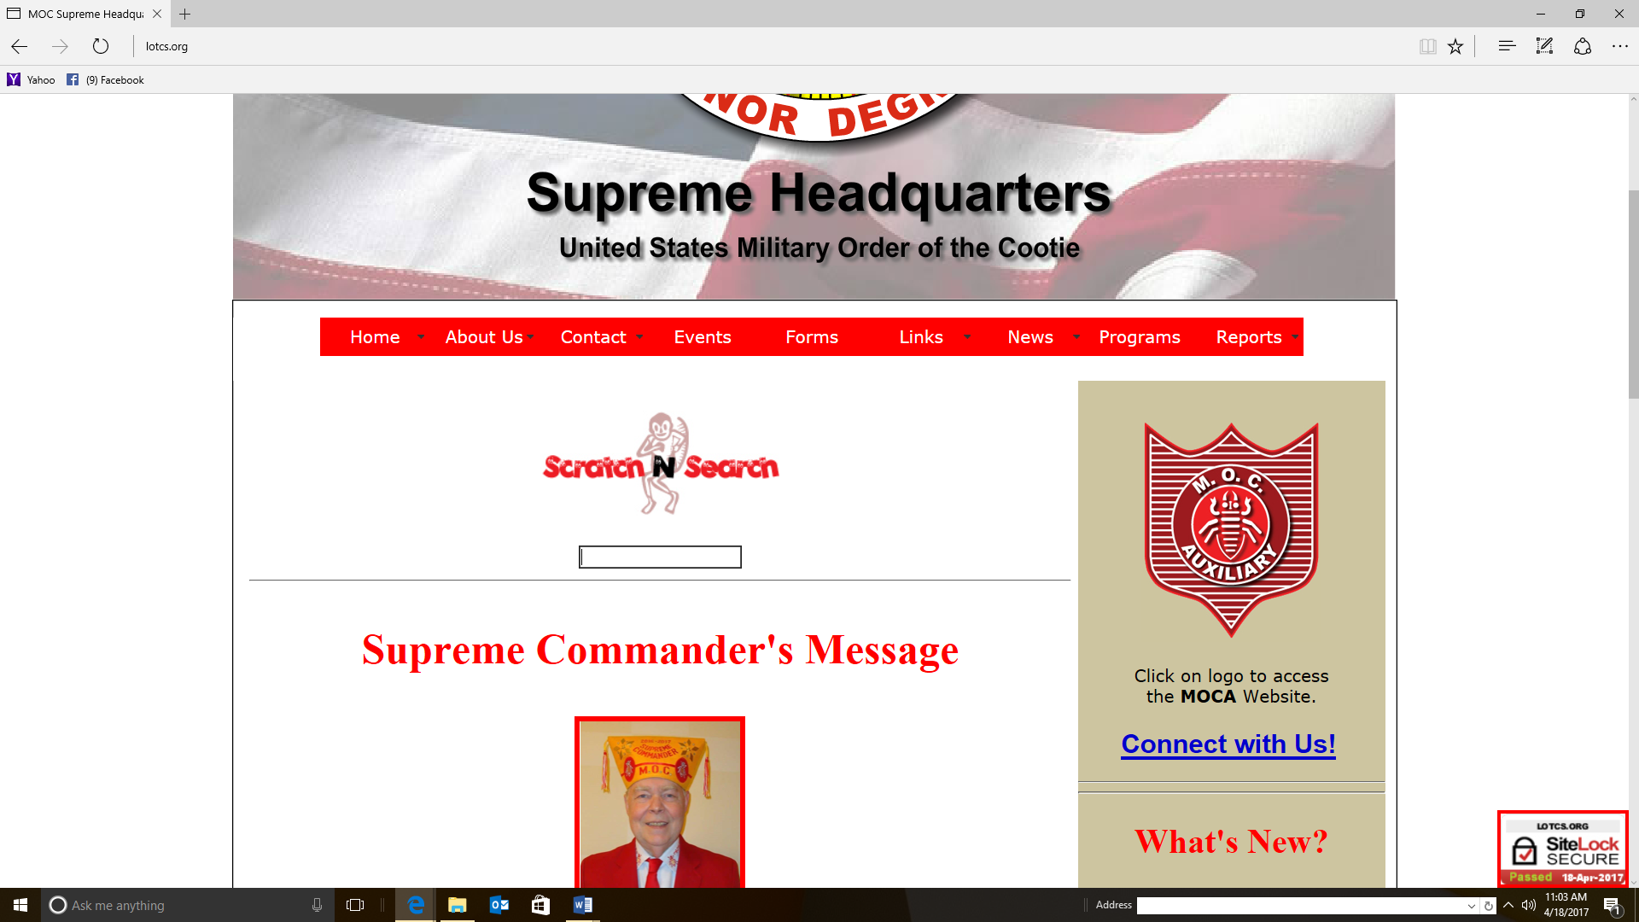

Start to type ‘sky pilot’ in the block and a small menu will appear. Choose “Sky Pilot Reports”.

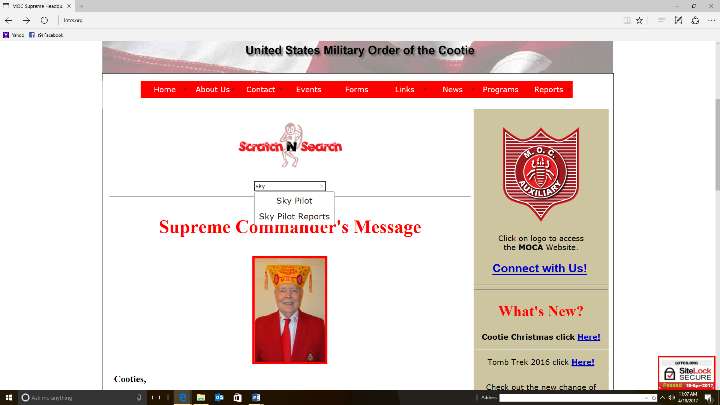
The “Sky Pilot Report Form” page will appear.

Complete the first section with the information required.

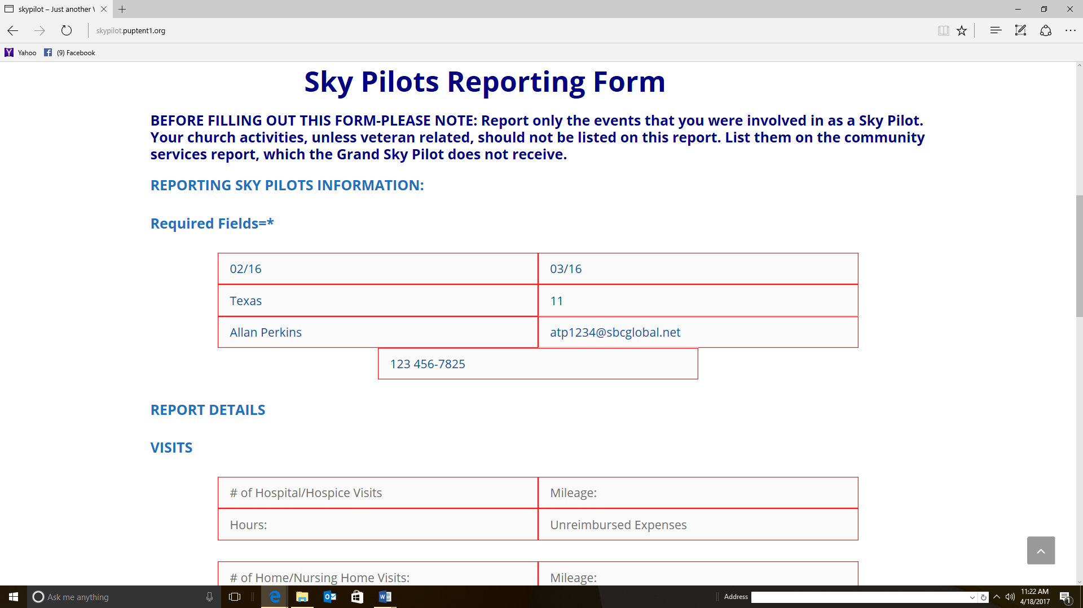

Finally, complete those blocks which document the work you have done. Just leave blank any blocks which do not apply.

Hit “Submit” and your work is done.

When you regularly report you efforts to assist our comrades, you make it easier for the Supreme Chaplain to make their reports. Then the Supreme Commander and staff will have a much better idea of the important work you do.

Supreme Awards

Angel Hero Pins

The Angel Hero Pin Award was conceived and designed by Supreme Chaplain Steve Smith prior to his passing. The original idea was to provide a small, but unique, award for the Supreme Chaplain to present, in the name of the Supreme Commander, to those Cooties and VFW members who are caught doing some significant kindness for another veteran.

It was later decided that a small number (3-5) of the awards would be given to each of the members of the Supreme Council of Administration to present to worthy Cooties as they travel though out the Cootie Year. The Supreme Chaplain administers the program.

Additionally, with the Supreme Commander’s approval, the Supreme Chaplain may also provide the award elements to the Grand Chaplains to present as they see Cooties perform compassionate services, above and beyond the norm, for other veterans.

The award consists of a pin which represents an angel, with the well-known ‘happy face’ head, and an attached ‘business-card’ sized card which explains the significances of the award.

The attached card reads:

Unsung Hero Award
You have been caught doing something good! Your actions have brought credit to the Military Order of the Cootie and the Veterans of Foreign Wars. On behalf of the Supreme Commander, the Supreme Chaplain wishes to recognize your good works and efforts. (This statement is followed by the current Supreme Chaplain’s email)

This award should not be presented to a Cootie for ‘routine Cootie hospital work’, or for just doing their job. Award presenters should keep their eyes open for the impulsive good deed, which is above what would normally be expected.

Sky Pilot of the Year

As we said earlier, when we looked at counseling, Chaplains are critical to the mission of the Cooties. They help each Cootie and Auxiliary member keep up their spiritual health while visiting patients in hospitals and nursing homes. The professionalism of our Sky Pilots in performing their duties also add to our scratches, meetings and social events. Then, recognizing that many of our Sky Pilots see their work as an avocation, it is only natural that we would want to recognize the best of ourselves. Nominations may be submitted by Pup Tent Seam Squirrels, Grand District Commanders, Grand Commanders, and Supreme Council of Administration members. However, as a Sky Pilot, there is nothing saying that, if you know a deserving comrade, you cannot bring them to the attention of the commander to nominate.

Each year the Supreme Commander provides instructions on the Supreme Sky Pilot of the Year program in their Program Book. While there are some slight changes from time to time, the program operates pretty much the same from year to year. You should check the current Program Book to confirm the instructions for the current year.

However, nomination letters must be sent to the Supreme Chaplain before 1 June of the program year and should be written on MOC stationary. Nomination letters should be carefully written to include the facts, events and activities which show your Sky Pilot is most deserving of the award. Submissions should be kept to one or two pages. Merely stating that your Chaplain performs their duties well, even for many years, might not be enough to earn the Supreme Award. A sample nomination letter is provided on page H-44.

After the deadline for submissions, (1 June) the Supreme Chaplain will convene a committee of not less than three persons to review the submitted nominations and choose the Supreme Chaplain of the Year. The committee members will not be VFW or MOC members, however they will be persons who are knowledgeable and fully understand the duties and responsibilities of the Sky Pilot.

Also, a Sky Pilot may only be presented the Chaplain of the Year Award only once at any one level. For example, they may be recognized at the Grand and Supreme Levels. But, they may not be presented the award at the Grand level more than once, or the Supreme Level more than once.

While there may be local instructions for your Grand, as a rule, lower levels of the MOC should consider following these instructions for their program. We have many great Sky Pilots and outstanding Chaplains. They all deserve recognition for their hard and dedicated work in support of our members.

Military Order of the Cootie
Sky Pilot’s Manual and Handbook

Handbook

Prayers found in the Ritual

Scratch Opening Prayer
Prayer for the National Home
Evening Prayer (to be used at 9:00 P.M., or as close as practical)
Alternate Prayer (To be used at other times)
Prayer at the Closing of a Scratch
Prayer for Newly Installed Officers
Prayer at Pup Tent Initiation
Prayer for Draping the Charter
Prayer at Memorial Service
Prayer for the Burial Ritual
Ritual Prayer
Committal Prayer
Benediction

Simple Table Grace

Holy God, thank you for this food, and bless those who prepared it.
Amen.

Allan T. Perkins
Chaplain, Grand of Texas

Dear God, we thank you for your gifts of food, family, and Friends.
We ask Your blessing on all present and all who prepared this meal.
Amen

Allan T. Perkins
Chaplain, Grand of Texas

A Native American Benediction

May your way be blessed with life by the unifying force of the Great Holy Spirit.

Cherokee Prayer
From “A Cherokee Feast of Days”
Compiled by Joyce Sequichie Hifler

Table Grace for a Banquet
(General)

Lord, we thank you for being with us this evening.
We thank you for this food, and for those who prepared it with their hands, heads, and hearts.
We are here this evening to (What is the purpose for the event?) We would ask you, Lord, to help us honor this event and each other this evening.
And, as we leave this place this evening, Lord, be with us as we go back to our homes. Keep us safe and help us to do those things which are honorable to you and our fellow veterans.
Amen

Allan T. Perkins
Chaplain, Grand of Texas

Installation Banquet Invocation

O Gracious Heavenly Father, we pause and bow our heads before you to humbly ask your blessing and to give thanks for the goodness you have shown us.

May your blessings be graciously bestowed upon (name the organization holding the banquet) in the fulfillment of your divine will as we serve other veterans and their families.

Remember especially in your love, the Auxiliary who give so much of their time and talent to this organization. And now, O Lord, bless us and these, your gifts of food and drink of which we are about to receive to our bodies. In your Holy Name we ask and pray.

Amen.

Dale Iannello
Chaplain, Grand of Washington

Installation Banquet Benediction

Heavenly Father, we thank you for the time spent in fellowship with each other tonight. Let us depart in peace, love and charity with our comrades and sisters. May we be joined together in the common goal of service to our God and our Country. Let us drive safely and carefully to our homes, and may God’s blessing be with us all.

Amen

Dale Iannello
Chaplain, Grand of Washington

Refrain from
Gather The Spirit

Gather in peace, gather in thanks!
Gather in sympathy now and then!
Gather in hope, compassion and strength!
Gather to celebrate once again!

By Jim Scott
1945 –

Prayer of Hope

Looking behind I am filled with gratitude,
Looking forward I am filled with vision,
Looking upward I am filled with strength,
And looking within I am filled with peace.

Allan T. Perkins
Chaplain, Grand of Texas
Memorial Service for a Cootie

[Instructions are given in parentheses (), while places which require customization for each Cootie are provided in parentheses and italicized form. TAPS are normally not played here as they are played at the gravesite, when military honors are offered.]

Opening remarks
“Blessed be to God … the Father of Mercies and God of all comfort: who comforts us in all our affliction so that we may be able to comfort those who are in any affliction with the comfort with which we ourselves are comforted by God.”

We are here to remember (Use the deceased’s full name). (Provide a few lines about them. Identify their military service, and VFW/Cootie career.)

Song
(A hymn or other appropriate song of the family’s choice)

Obituary
(May be given by a close family member or the chaplain officiating. The full obituary should include all major life events, parents, siblings, spouse, children, grandchildren, and others the family wishes.)

Family Remarks
(If they desire, plan on no more than four family members speaking for approximately 3-4 minutes each. Each should be briefed in advance and coordinate to ensure they do not all repeat the same thing. These remarks should include personal stories and examples of the deceased’s positive traits.)

Song
(Optional. Follow the same rules as above.)

Homily
On a separate page

Song
Amazing Grace (or other hymn the family requests.)

Closing words and Prayer
Let us remember the good work (Cootie’s first name) did to serve the community and his/her fellow veterans. Let us remember the good times, jokes and love that was (Cootie’s full name). (The words can be changed slightly for particular circumstances.)

Please, pray with me.

Lord God each of us worship. Bless and touch (Spouse), her/his children, family and friends (Customize for this Cootie). Give each of us the strength to carry on, the compassion to help each other, the joy to laugh again, and the wisdom to learn from (Cootie’s first name) example.

Amen and be blessed.

(An optional Benediction may be used, especially if there will be no graveside service.)

The funeral director will usually give those present instructions from here.

Optional Funeral Benediction

Spirit of life, As we commit (Cootie’s Full Name) in to your loving arms, we pray that you bestow on (Cootie’s first name’s) family and all those who grieve him/her, compassion and gratitude for his/her gifts in life – gifts that live on and on through his/her loved ones.
By enacting kindness we honor (Cootie’s first name). We pay it forward. Let us resolve to honor (Cootie’s first name) by searching our own hearts, and uprooting any barriers that keep us from loving freely. Let us leave this sacred hour a little more compassionate and peaceful, and more open to others in our lives.
Let us lift up our hearts in gratitude for his/her life. Let us resolve to honor his/her living spirit by seeing more clearly the beauty the divine has given us in the natural world, in music, in the abundance of all things—and especially in one another.

Amen
Traditional Funeral Service

Opening
Maybe an appropriate scripture, or simply; “We are here to celebrate the life of (Cootie’s full name), who passed from this world on (Date).”

Hymn or reading
A hymn, song, reading or appropriate poem of the family’s choosing.

Comforting words
May be a comforting scripture such as Psalm 23, Psalm 121, Matthew 5:4, or John 14:27. This may also be a reading or poem of a comforting nature.

Prayer
Deliver a prayer asking Divine blessings of comfort for those present, and peace for the deceased.

Obituary (Optional)
(May be given by a close family member or the chaplain officiating. The full obituary should include all major life events, parents, siblings, spouse, children, grandchildren, and others the family wishes.)

Hymn
A hymn, song, reading or appropriate poem of the family’s choosing.

Address or Homily
Should be short (5-6 minutes) and comforting. It is sometimes helpful to make reference to the deceased in the homily.
Hymn
A hymn, song, reading or appropriate poem of the family’s choosing.

Closing
Appropriate concluding remarks, a prayer of benediction, or short words of encouragement.

Funeral Homily for a Cootie

(Sections to be customized are in parentheses and italicized.)

When someone close to us passes on we have many conflicting feelings. Grief, sadness, loss and anger; sure. But, if they had suffered for a long while, we might even feel relief or gladness that our loved one is no longer in pain, or suffering. How do we deal with these feelings?

As he was completing his earthly ministry, Jesus knew his disciples would have all of these same feelings. So, he tried to prepare them. He told them what would happen and what they should do. He told them He was going to ‘God the Father’, but would send the ‘Holy Spirit’ to comfort them. In the process, He offered what I believe is the most beautiful passage of comfort ever penned.

“Peace I leave with you, my peace I give unto you: not as the world giveth, give I unto you. Let not your heart be troubled, neither let it be afraid.”

Jesus makes a point of telling his disciples this was not a ‘maybe promise’. This is not a case of ‘I’ll be with you; unless things get rough.’ It’s “I’m making this promise to you and you can trust it.” Others in the world may make promises they can’t keep; but, you can rely on this promise, just as you could rely on me on earth. The disciples trust his promise, and He kept the promise. And, we today can rely on that same promise.

Peace I leave with you, my peace I give unto you.

Peace, a chance to quiet the emotions.

He didn’t say we would forget our friend – our loved one. We all know we remember. But when we can sooth the grief, loss and anger; we can remember the good times. The times when we laughed with (Cootie’s first name). The times when we knew love with (Cootie’s first name). The times when we learned important lessons from (Cootie’s first name).

Peace I leave with you, my peace I give unto you.

There is another important point a mentor of mine reminded me of many years ago. Jesus made the promise, and the Holy Spirit is the great comforter. But sometimes grief requires a human touch. It’s up to us to provide the hug. It’s up to us to listen to the stories. Sometimes it’s up to us to just sit quietly and hold a grieving friend or loved one’s hand. And, sometimes it’s up to us to tell the joke which makes our friend or loved one laugh and remember better times.

Jesus made the promise; but we have the honor to help implement it.

Peace I leave with you, my peace I give unto you. May each of us feel that peace; and, be honored to help another feel it.

Committal Prayer

Divine Father, we thank You for (Cootie’s first name)’s life here on this earth, and we recognize that the body that lies before us is not (Cootie’s first name), but rather the house in which he /she lived. We acknowledge that (Cootie’s first name) is rejoicing, even now, in Your very presence, enjoying the blessings of Heaven.

Father, we commit his/her body to the earth, from which our bodies were originally created, and we rejoice in the fact that his/her spirit is even now with You, the Father of spirits.

We anticipate the day when spirit and body shall be united again at the coming of the Lord, and we find great comfort in knowing that we shall forever be together with the Lord.

We thank You Father, that in the days, weeks, and months to come, these realities and the abiding presence of Your Spirit will especially strengthen, sustain, and comfort (Cootie’s first name) friends and family.

Amen.

Hide Gimlet  (Sprig of Evergreen)  ON BEHALF OF (identify your pup tent, post or grand), I PRESENT THIS TRIBUTE AS A SYMBOL OF OUR UNDYING LOVE OF OUR COMRADE |  | Blanket Bum  (White Flower)  I PLACE THIS SYMBOL OF PURITY UPON THIS MEMORIAL AND MAY EACH FUTURE GENERATION EMULATE THE UNSELFISH DEVOTION TO DUTY EVEN TO THE LAST OF OUR COMRADES
Provost Marshal  (Laurel Wreath)  WE PLACE THIS LAST TOKEN OF AFFECTION FROM HIS COMRADES IN ARMS UPON THE MEMORIAL OF OUR DEPARTED COMRADE AND CROWN HIS MORTAL DUST WITH THIS SYMBOL OF VICTORY. |  | Seem Squirrel  (Small American Flag)  ON BEHALF OF OUR GLORIOUS REPUBLIC, FOR WHOSE INTEGRITY OUR COMRADE OF THE VETERANS OF FOREIGN WARS ENLISTED AND SERVED, WE PLACE UPON HIS MEMORIAL THIS EMBLEM OF OUR COUNTRY, A COUNTRY WHOSE ARMS ARE ALWAYS OPEN TO SHELTER THE OPPRESSED.

Palm cards may be cut out and held in the hand to help Pup Tent officers to provide a simple Cootie ritual.

Dale Iannello
Chaplain, Grand of Washington

Four Chaplains Remembrance Prayer

Holy Lord, as we come together today to remember four brave men of God. We thank You for Your presence with us.

As we meet together today, we ask you to touch our minds, and hearts, and souls.

Touch our minds, Lord, that we may remember the sacrifices willingly made on the Dorchester that night; the lives lost, and those saved by these four men of God.

Touch our hearts that we might feel compassion for the families who even now mourn those lost that night.

Touch our souls, Lord, that we might leave this sacred place today with a renewed eagerness to serve and sacrifice for those souls you have placed before us.

For all this, Lord, we will be grateful and thank You.

Amen

Allan T. Perkins
Chaplain, Grand of Texas

Veterans Day Breakfast Invocation

Heavenly Father, we gather here today in remembrance of those veterans who have served their country with honor and pride; some making the ultimate sacrifice, to protect the freedoms that we now enjoy. We pray for your continued protection of those who are now serving in harm’s way. Bless also their families as they wait for their loved ones to come home. As we partake of this meal together today let us always remember the sacrifices of all veterans, past and present, have made and keep them always in our prayers.

Amen.

Dale Iannello
Chaplain, Grand of Washington

Veterans Day Breakfast Benediction

Divine Creator, as we go to the safety of our homes, let us not forget the words spoken here today concerning our veterans. Let us always keep in the forefront of our thoughts the sacrifices of those brave men and women who have fought so gallantly for our freedom. Bless our country and keep us safe from those who would wish to do us harm.
Amen.

Dale Iannello
Chaplain, Grand of Washington

Veterans Day Prayer

Holy Lord, we come together today not to morn or remember our lost or war dead.

But today we come together to celebrate our veterans.

We know we have lost many who have served our country, and we celebrate their service and achievements this day.

Even more importantly, Dear Lord, we thank and celebrate those veterans who are still with us.

Those friends, family members, coworkers, and others we have come to meet who dedicated a portion, or indeed all, of their lives to serve in the armed forces and defend their fellow citizens.

Lord, we ask that you touch our hearts so that we do not merely murmur words of thanks, but genuinely care for and respect each and every veteran.

Help us to learn their stories, to know when and where they served. Help us to feel gratitude for the sacrifices they made. Help us to know how they gave up the joys of friends and family to allow us to experience these same joys.

Dear Lord, we come humbled and grateful for each veteran, for each sacrifice they made.

We thank you for your gifts and blessing.

But most of all, Dear Lord, on this Veteran’s Day we thank you for the gifts of each and every veteran who has served and sacrificed to give us the freedoms you would wish for us.

Amen

Allan T. Perkins
Chaplain, Grand of Texas

Veterans Day Benediction

Holy One, as we leave this place we ask you to give us strength.

Give us strength of mind; to remember the deeds and sacrifices of these, our veterans, we recognize this day.

Give us strength of emotion; to miss those who are not us, and to laugh with those who are.

Give us strength of body; to do those deeds that honor you and these veterans, our examples of courage.

Give us strength of spirit; to keep reverent our relationship with you, and our respect for these, our veterans.

Finally, Holy One, give us the strength of character; to defend our nation with might and surround the needy and our children with love.

Allan T. Perkins
Chaplain, Grand of Texas

POW/MIA Remembrance Day Prayer

Holy Lord we each worship, we thank you for your loving presence among us.

We come together today in joy and sorrow; to remember.

We come to remember and recognize those of our comrades who did not return home with us.

We recognize that more than 80,000 of our comrades, family and friends to so many, did not return from our nations conflicts.

We are saddened because we miss them. We miss the comrade standing proud, shoulder to shoulder with us. We miss the father, brother, daughter. We miss their love and laughter. We miss the friend and the years of shared activity.

We came to remember. So we also remember the joy of comrades after shared challenges.

We came to remember the warm love and understanding of missing family members. How they shared the simple joys of life; a birthday, a wedding, a walk in the woods.

We came to remember friends, and the joys of friendship; shared experiences, emotions and endeavors.

Holy Lord, we came to remember more than 80,000 comrades, friends, and family members. Each are important to us, because each are held dear by some of us who are returned.

Holy Lord, we ask you to comfort each of our missing comrades and hold them close. We also ask your blessing for those comrades, family members and friends who still grieve for our missing. Bless their souls and comfort them.

Finally, Holy Lord, we ask for divine strength. Strength of mind to allow us to continue to remember our 80,000 plus missing comrades. Strength of body and will to continue advancing their cause. And, strength of spirit to share your divine love with those most in need.

Amen

Allan T. Perkins
Chaplain, Grand of Texas

Voice of Democracy Luncheon Invocation

O Gracious Heavenly Father, we pause and bow our heads before you to humbly ask your blessing and to give thanks for the goodness you have shown to us. May your blessings be graciously bestowed upon these young people in the fulfillment of your divine will.

For it is the youth of our country that will pass on to future generations the precept that freedom is never free and that the defense of our belief in freedom is won at the cost of the lives of brave men and women that have gone before them. Continue to watch over those who even now guard the gates of freedom and bring them home safely to their friends and family.

And now, O Lord, humble our hearts as we partake of this food and drink to strengthen our bodies for your service. In your Holy Name we ask and pray.

Amen.

Dale Iannello
Chaplain, Grand of Washington

Voice of Democracy Luncheon Benediction

Heavenly Father, we thank you for the time spent in fellowship with each other today. May we be joined together in the common goal of service to our God and our Country. Let us drive safely and carefully to our homes, and may your glorious light be ever present among us all.

Amen

Dale Iannello
Chaplain, Grand of Washington

The Young Dead Soldiers Do Not Speak

The Young Dead Soldiers do not speak.
Nevertheless they are heard in the still houses: who has not heard them?

They have a silence that speaks for them at night and when the clock counts.
They say, We were young. We have died. Remember us.

They say, We have done what we could but until it is finished it is not done.
They say, We have given our lives but until it is finished no one can know what our lives gave.

They say, Our deaths are not ours: they are yours: they will mean what you make them.
They say, Whether our lives and our deaths were for peace and a new hope or for nothing we cannot say: it is you who must say this.

They say, We leave you our deaths: give them their meaning: give them an end to the war and a true peace: give them a victory that ends the war and a peace afterwards: give them their meaning. We were young, they say.

We have died. Remember us.

Archibald MacLeish,
Poet, 1892-1982

In Flanders Fields

In Flanders fields the poppies blow
Between the crosses, row on row,
That mark our place; and in the sky
The larks, still bravely singing, fly
Scarce heard amid the guns below.

We are the Dead. Short days ago
We lived, felt dawn, saw sunset glow,
Loved and were loved, and now we lie
In Flanders fields.

Take up our quarrel with the foe:
To you from failing hands we throw
The torch; be yours to hold it high.
If ye break faith with us who die
We shall not sleep, though poppies grow
In Flanders fields.

John McCrae, Surgeon, Canadian Army
1872-1918

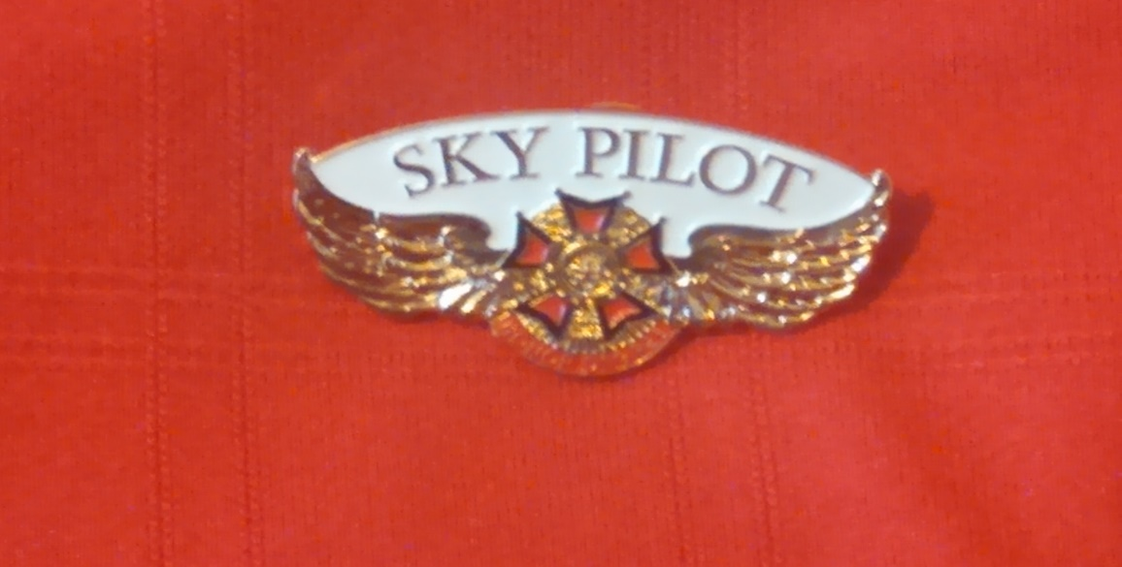
We all hope you are feeling better …

From the desk of the Supreme Chaplain

With Sincere Sympathy …

From the desk of the Supreme Chaplain

Just a note …

From the desk of the Supreme Chaplain

We all hope you are feeling better …

From the desk of the Grand Chaplain

With Sincere Sympathy …

From the desk of the Grand Chaplain

Just a note …

From the desk of the Grand Chaplain

Military Order of the Cootie
Blue Bug Pup Tent #76
Grand of Texas
1976 Bugcastle Road
Bugville, Texas 77180

TO: Supreme Chaplain 1 April, 2015
From: Seam Squirrel
Blue Bug Pup Tent #76

Subject: Supreme Chaplain of the Year

I am honored to nominate Sky Pilot Billy C. Divine for the Supreme Chaplain of the Year Award. Billy Divine has been serving Pup Tent #76 as Sky Pilot and Hungry Cootie since 1995. If there is a pup tent, district or grand event, Sky Pilot Billy is there, not only providing prayers, but also setting the example for care and compassion.
Whenever there is a hospital visit, Chaplain Billy is there doing everything he can. He has been calling bingo at the monthly Pup Tent #76 ‘Cootie Bingo’ events at the Bugville VA Medical Center for almost twenty years. He has also been a key leader for the annual Cootie Valentine events for fifteen years. For the last five years he has coordinated these events with the medical center staff, ensuring they go off without a hitch and that the needs of each patient is met. In fact, Billy Divine sets the example by going to every grand hospital event in clown gear and encouraging other cooties to do the same. At these events, and wherever he is, Sky Pilot Billy takes time to talk to the patients and meet their needs. Billy Divine regularly teaches that cooties are there to serve veterans and shows how it’s done by his example.
In addition to his Cootie and VFW duties, Billy Divine serves as a volunteer at the Bugville VAMC at least twice a week. He works in the lobby helping veterans and their family navigate the campus. On any one day, Sky Pilot Divine will assist from 75 to 100 veterans. He also serves on three different medical center committees, representing the patients and ensuring they are well served. Additionally, Billy serves as the MOC VAVS Representative for the Bugville VAMC. In fact, the volunteer efforts of Sky Pilot Billy at the VA Medical Center have been so unique that he was named Bugville VAMC 2014 Volunteer of the Year, and one of the 2014 Texas Medical Center Volunteers of the Year.
Sky Pilot Divine ministers to pup tent members, and their families, in any way he can. If he knows a member is ill, he sends a card and visits them when appropriate. He typically sends 15-20 cards a month. He is always available to speak to a member and counsel them if need be. He regularly serves at funerals for VFW and Cootie members, ensuring the family receives the services they require.
However, Sky Pilot Billy does much more. In addition to everything he does to serve our members, their families, and other veterans, he actively spreads the word about the MOC and our mission everywhere he can. Striving to recruit new Cooties and VFW Members. Showing them what it means to be an MOC member by his example. He even goes so far as to help train new VFW and MOC chaplains.
In addition to his duties with the Pup Tent, Billy Divine serves as Grand Chaplain. He also has served his VFW Post as Chaplain since 1993 and as VFW District 4 Chaplain for fifteen years. Additionally he has been serving as Service Officer for VFW Post for six years.
In short, Sky Pilot Billy C. Divine ministers to Cootie and VFW members, and their families, in any way he can, setting the example in love, compassion and care for all to follow. He is most deserving of recognition as Supreme Chaplain of the Year,

Yours in LOTCS,

Carl Louse
Seam Squirrel, Pup Tent #76

Memorial Prayer

Rest eternal grant him, O Lord, and may light perpetual shine upon him.

From Unvirtous Abbey on the passing of Tim LaHaye

Memorial Blessing
(A variation on an old Irish piece)

May he/she be blessed as he blessed others in life.

The Snow Rose Ceremony

(If you want context for this ceremony, Read The Snow Rose by the same author.)

Preparations

- Before the service where this ceremony is used, a time should be found to integrate it into the service. Some place it just before the benediction.
- The officiant, or other person appointed to perform this ceremony, should learn as much as possible of the deceased’s positive traits, morals, and ethics.
- Before the memorial service or other service were this ceremony is to be used, a near perfect white rose should be obtained.
- The rose should stand alone. No other flowers or greens should be attached.
- Before the service is to begin, the rose should be placed in a spot convenient to the officiant but hidden from the audience.

The Ceremony

“Many years ago, a story was written which suggested a new way to look at services like this one. As the story goes, a friend of an old retired veteran told him a story from his childhood.

The friend spoke of when he was a young boy and lost his parents to a tragic accident. His grand-father took him in and lovingly cared for him. But the boy could not stop crying for his parents.

The grand-father took the boy into his arms and set the child on his lap. The grandfather told his grandson that he missed the boy’s parents also. Then he told the boy the story of The Snow Rose. A mystical flower, thought to be the most perfect white rose.

It is thought that when a person has passed, who loved and cared for others and, and was loved, and when a tear of grief was shed, The Snow Rose would appear.

The day came when a service like this one was held for the child’s parents, he was led to visit his parents one more time. As he looked down on his mother the child was still crying. A tear fell on her hand. That was when The Snow Rose appeared in her hand.

The child missed his parents the rest of his life, especially when he remembers a loving moment. But, he never again cried for them, or grieved so fiercely.

We have heard today that (Name of the deceased) is (remind those present that the deceased loved many people and of their positive traits, morals, and/or ethics).

When The Snow Rose appears, we do not have to continually morn to the point of suffering. Of course we will miss (deceased’s name). As time goes by, it will be easier. Even so, from time to time, we will miss (deceased’s name), and will feel sad. That is life. But when we see The Snow Rose, we know (deceased’s name) is okay, he/she is wrapped in loving arms. We do not have to suffer the pain we feel now, in the long term.”

(At this point, without saying another word, retrieve the hidden rose and place it at an appropriate spot for all to see, and be seated again. [In/on the coffin, or next to the urn, etc.])

